Project 1 – Queue Simulation Report
ENEL 573 L01 – Computer Networks, Fall 2026
Name: Temuulen Ankhbayar Student ID: 30188632
Date: October 16, 2026

Question 1 – Generating exponential random variables
With 1000 samples and λ = 75, the sample mean came out 0.78% from the theoretical 1/λ and the variance 6.08% from 1/λ², which is within normal sampling error for n = 1000.

Derivation (inverse-transform method)
The CDF of an exponential random variable X with rate λ is:
F(x) = P(X ≤ x) = 1 − e^{−λx}, x ≥ 0
Set F(x) equal to a uniform random variable U ~ U(0,1) and solve for x:
1 − e^{−λx} = U ⇒ e^{−λx} = 1 − U ⇒ −λx = ln(1 − U)
x = −(1/λ) · ln(1 − U)
So each sample is X = −ln(1 − U)/λ. Since random() returns values in [0, 1), 1 − U is never 0, so the logarithm is always defined.
Theoretical mean and variance. With the pdf f(x) = λe^{−λx}, integration by parts gives E[X] = ∫ x·λe^{−λx} dx (0 to ∞) = 1/λ and E[X²] = ∫ x²·λe^{−λx} dx (0 to ∞) = 2/λ², so Var[X] = E[X²] − (E[X])² = 2/λ² − 1/λ² = 1/λ².
Theoretical values for λ = 75:
E[X] = 1/λ = 1/75 = 0.013333 Var[X] = 1/λ² = 1/5625 = 0.00017778

Code (ENEL573_Project1_Q1.py)
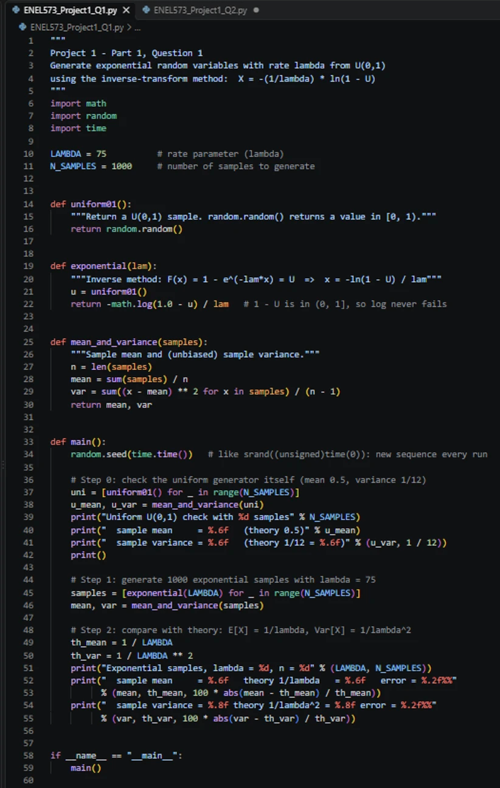
Screenshot 1. ENEL573_Project1_Q1.py – exponential generator using the inverse method.

Output of one run
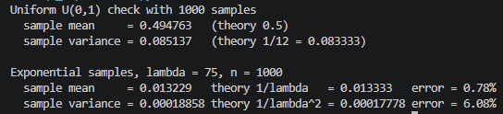
Screenshot 2. Output of python ENEL573_Project1_Q1.py.
The sample mean and (unbiased) sample variance of the n = 1000 generated samples x₁ … xₙ are calculated as:
x̄ = (1/n) · Σ xᵢ s² = (1/(n − 1)) · Σ (xᵢ − x̄)²
Quantity | Simulated (n = 1000) | Theory | Error
Mean (s) | 0.013229 | 1/75 = 0.013333 | 0.78%
Variance (s²) | 0.00018858 | 1/75² = 0.00017778 | 6.08%
The error is calculated as |simulated − theory| / theory × 100%:
Mean: |0.013229 − 0.013333| / 0.013333 × 100% = 0.78%
Variance: |0.00018858 − 0.00017778| / 0.00017778 × 100% = 6.08%
Both values are close to the theoretical ones, so the 1000 generated samples agree with an exponential random variable with λ = 75.

Why the results are reasonable
- The uniform generator passes the basic check first: mean 0.4948 vs 0.5 and variance 0.0851 vs 0.0833.
- With only 1000 random samples, small differences from theory are expected: the mean is within 1% and the variance within about 6% of the theoretical values, and both get closer as the number of samples grows.
- The seed changes each run, so the exact numbers differ from run to run but stay this close to theory.

Question 2.1 – The M/M/1 discrete event simulator
The simulator pre-generates every arrival, departure and observer event in [0, T], sorts them by time, and walks the list once while updating three counters; E[N] and P_IDLE come from what the observers see.

Variables
Symbol | Meaning | Value used
λ | Average packet arrival rate (packets/s) | ρC/L, from 20.8 to 79.2
L | Average packet length (bits) | 12000
C | Link transmission rate (bits/s) | 1 000 000
ρ | Utilization = λL/C | 0.25 to 0.95, step 0.1
α | Observer rate (events/s) | 5λ (manual asks for at least 3λ)
T | Simulation time (s) | starts at 1000, grows until stable
Na, Nd, No | Counters: arrivals, departures, observations | –

How it works
- Arrivals. Inter-arrival times are exponential with rate λ (the Question 1 generator), added up until the time passes T.
- Departures. Each arriving packet gets an exponential length with mean L, so its service time is length / C. If the server is busy, the packet starts when the previous one leaves; otherwise it starts on arrival: departure = max(arrival, previous departure) + service time. Departures after T are dropped.
- Observers. A separate Poisson stream with rate α = 5λ.
- Sort. All events go into one list sorted by time; this list is the DES.
- Process. Each event is handled in order. Arrival → Na += 1. Departure → Nd += 1. Observer → No += 1, the packets in the system are Na − Nd, add that to a running sum, and if it is 0 count one idle observation. Walking the sorted list once with a for-loop does the same job as the manual’s “process the event, then delete it from the DES”: every event is used exactly once and never revisited.

Performance metrics
E[N] = (1/N_{o}) · Σ_{k=1..No} (N_{a} − N_{d}) at observer k
P_{IDLE} = (number of observers that saw N_{a} − N_{d} = 0) / N_{o}
In the code, last_departure holds the departure time of the previous packet, sum_packets adds up Na − Nd over all observer events, and idle_count counts the observer events that found Na − Nd = 0. simulate() returns sum_packets / No and idle_count / No.

Stability check
As the manual describes, each ρ is run for T = 1000 s, then 2T, 3T, … and each result is compared with the previous run. A result is accepted once both E[N] and P_IDLE differ by less than 5% from the previous run two times in a row. The shortest possible stable T is therefore 3000 s. In the final run every ρ settled at 3000 s except ρ = 0.85, which needed 6000 s.

Code (ENEL573_Project1_Q2.py)
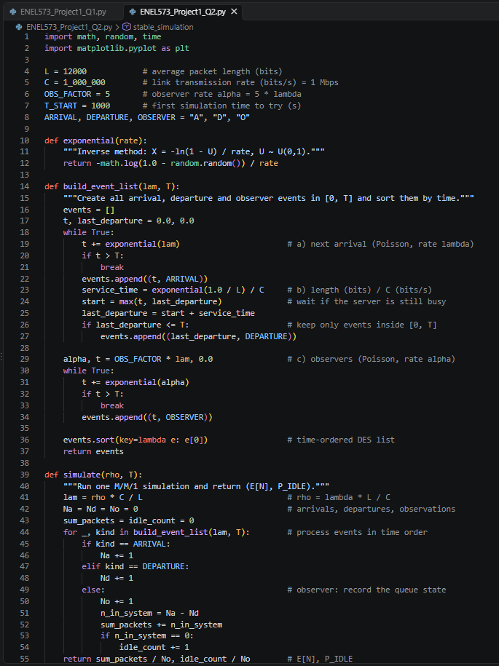
Screenshot 3. ENEL573_Project1_Q2.py (part 1)
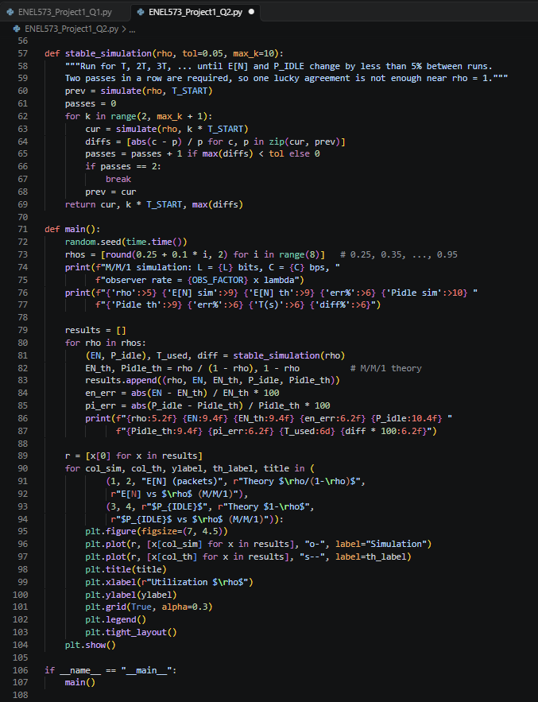
Screenshot 4. ENEL573_Project1_Q2.py (part 2)

Screenshots 3 and 4 show the whole file. Lines 71–104 loop over ρ = 0.25 … 0.95, print the results table and draw the two graphs with matplotlib.

Question 2.2 – Results for L = 12000 bits, C = 1 Mbps
For ρ = 0.25 to 0.85 the simulator matches M/M/1 theory within 1.5% for E[N] and 1.4% for P_IDLE; at ρ = 0.95 the errors rise to 5.1% and 4.3%. For each ρ the arrival rate is set to λ = ρC/L, the stable run is taken, and the result is plotted against the theoretical curve.

1. E[N] as a function of ρ
Theory for M/M/1: E[N] = ρ/(1 − ρ).
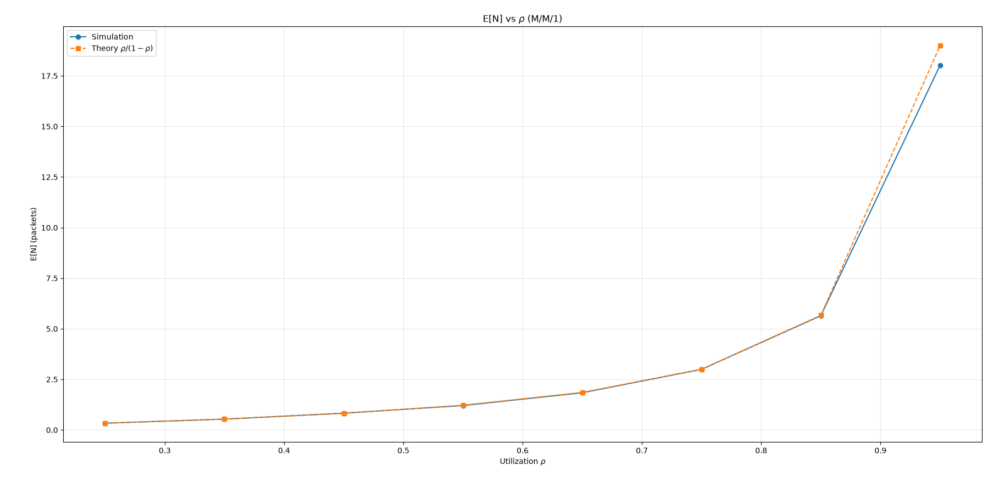
Figure 1. E[N] vs ρ – simulation (blue) and theory (orange).
E[N] grows slowly up to ρ ≈ 0.7 and then sharply: going from ρ = 0.85 to 0.95 more than triples it (simulated 5.65 → 18.03; theory 5.67 → 19.0). The simulated curve sits right on the theoretical one up to ρ = 0.85 and falls slightly below it at ρ = 0.95. As ρ approaches 1 the server is almost never free, so packets pile up and the queue becomes unstable at ρ ≥ 1.

2. P_IDLE as a function of ρ
Theory for M/M/1: P_IDLE = P(N = 0) = 1 − ρ.
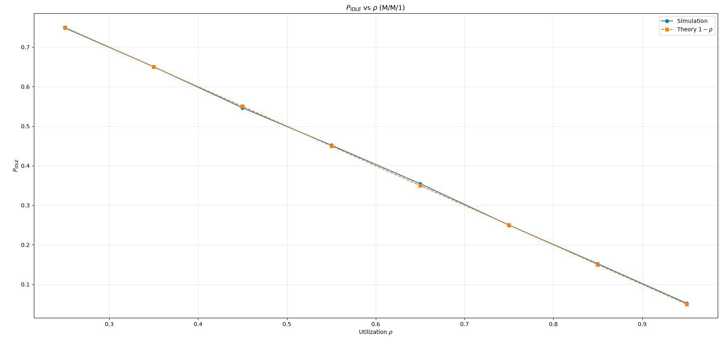
Figure 2. P_IDLE vs ρ – simulation (blue) and theory (orange).
P_IDLE falls in a straight line as ρ rises. This makes sense: ρ is the fraction of time the server is busy, so the rest of the time, 1 − ρ, it is idle. It is measured as the share of observers that found Na − Nd = 0.

Accuracy and stability per run
ρ | λ (packets/s) | E[N] error vs theory | P_IDLE error vs theory | Stable T (s) | Change vs previous T
0.25 | 20.83 | 0.55% | 0.21% | 3000 | 1.44%
0.35 | 29.17 | 0.50% | 0.04% | 3000 | 1.57%
0.45 | 37.50 | 1.50% | 0.62% | 3000 | 0.53%
0.55 | 45.83 | 1.32% | 0.40% | 3000 | 0.67%
0.65 | 54.17 | 1.00% | 1.30% | 3000 | 0.70%
0.75 | 62.50 | 0.13% | 0.08% | 3000 | 1.38%
0.85 | 70.83 | 0.35% | 1.34% | 6000 | 0.90%
0.95 | 79.17 | 5.12% | 4.27% | 3000 | 4.88%

Errors are largest at ρ = 0.95 (5.1% for E[N], 4.3% for P_IDLE). Near saturation the queue length varies the most, so a longer run (larger T) would bring these values closer to theory. The “Change vs previous T” column is the larger of the E[N] and P_IDLE changes between the last two runs.

Program output
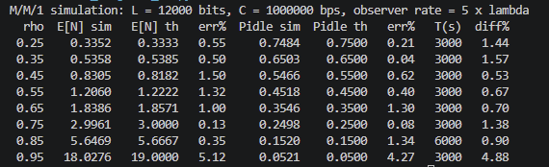
Screenshot 5. Output of python ENEL573_Project1_Q2.py (simulated vs theoretical E[N] and P_IDLE for each ρ).

Conclusion
The inverse-transform generator produces correct exponential samples, and the event-list simulator built on it reproduces M/M/1 theory for both E[N] and P_IDLE: within 1.5% for ρ ≤ 0.85 and within about 5% at ρ = 0.95.
- Near saturation (ρ → 1) the queue length grows sharply and results need longer runs to stabilise, which is why ρ = 0.95 has the largest error.

